*Don’t forget to hyperlink the events with your corresponding Shop URL!
In a few short weeks, MLB teams will gather in locations across Arizona and Florida to prepare for Opening Day with 4 weeks of Spring Training fun in the sun!
Year after year, baseball fans from across the country attend MLB's Spring Training, and this year will be no different. This special event is a fan favorite because it provides a rare opportunity to see many baseball teams play in close proximity to one another. Despite the fact that most teams are far from home, fans can revel in creature comforts of their hometown stadiums; including team mascots and culinary delights, such as cheesesteaks at the Phillies' stadium in FL, and Skyline Chili at the Cincinnati Reds stadium in AZ. If that wasn't enough, these typically are also the cheapest tickets that you will find for any team.
In the Cactus League, 15 teams play at 10 stadiums within 47 miles of each other in and around Phoenix, AZ. Because there are so many teams to see and so many games to attend, it comes as no surprise that the majority of attendees travel from out town. Beyond baseball, fans also relish the fact that they can soak up the sun with other activities like hiking or visiting breathtaking Sedona.
In the Grapefruit League, baseball fans can flock to see 15 teams warm-up for the season at 13 different locations. The Grapefruit League venues are certainly more spread out than in the Cactus League, which provides visitors the opportunity to visit either (or both) the Gulf and Atlantic coasts, as well as small-town cities in Central Florida. For fans who want to visit several venues and teams without a whole lot of driving, we recommend selecting the Tampa area as your home base. In Tampa, you will be able to check out the Yankees, Phillies, and Blue Jays. Within an hour's drive of Tampa you can also visit the Pirates, Orioles, and Tigers.
For the ultimate double-header experience, head to Florida in March so that you can attend both a Spring Training game AND one of the NCAA Basketball tournament games, which will be in Tampa on March 19 & 21.

Arizona D-backs:
Salt River Fields, Talking Stick, Scottsdale
Chicago Cubs:
Sloan Park, Mesa
Chicago White Sox:
Camelback Ranch, Glendale
Cincinnati Reds:
Goodyear Ballpark, Goodyear
Cleveland Indians:
Goodyear Ballpark, Goodyear
Colorado Rockies:
Salt River Fields, Talking Stick, Scottsdale
Kansas City Royals:
Surprise Stadium, Surprise
Los Angeles Angels of Anaheim:
Tempe Diablo Stadium, Tempe
Los Angeles Dodgers:
Camelback Ranch, Glendale
Milwaukee Brewers:
American Family Fields of Phoenix
Oakland Athletics:
Hohokam Stadium, Mesa
San Diego Padres:
Peoria Sports Complex, Peoria
San Francisco Giants:
Scottsdale Stadium
Seattle Mariners:
Peoria Sports Complex, Peoria
Texas Rangers:
Surprise Stadium, Surprise

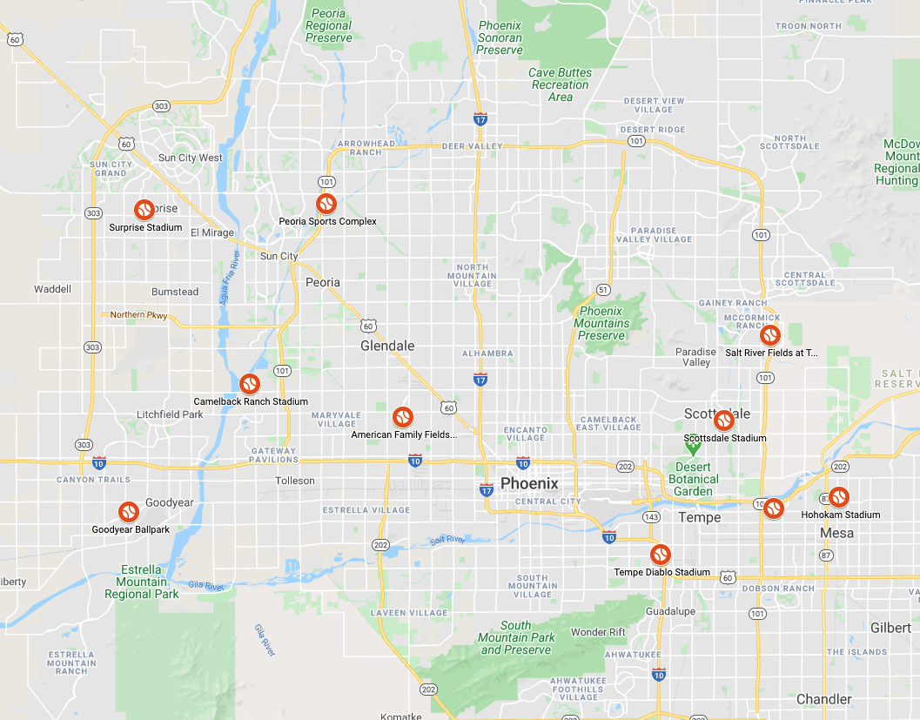
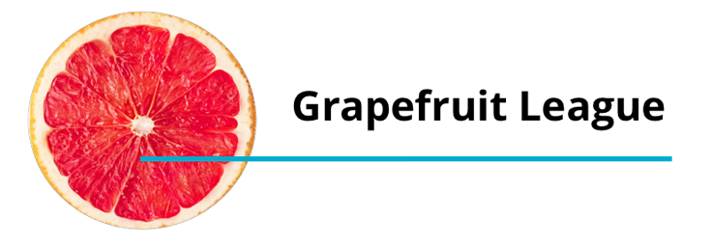

Detroit Tigers:
Joker Marchant Stadium, Lakeland
Atlanta Braves:
Champion Stadium, Lake Buena Vista
Houston Astros:
Osceola County Stadium, Kissimmee
Washington Nationals:
Space Coast Stadium, Viera
New York Mets:
Tradition Field, Port St. Lucie
St. Louis Cardinals:
Roger Dean Stadium, Jupiter
Miami Marlins:
Roger Dean Stadium, Jupiter
Minnesota Twins: Hammond Stadium, Fort Myers
Boston Red Sox:
JetBlue Park, Fort Myers
Tampa Bay Rays:
Charlotte Sports Park, Port Charlotte
Baltimore Orioles:
Ed Smith Stadium, Sarasota
Pittsburgh Pirates:
McKechnie Field, Bradenton
Philadelphia Phillies:
Bright House Field, Clearwater
Toronto Blue Jays:
FL Auto Exchange Stadium, Dunedin
New York Yankees:
George M. Steinbrenner Field, Tampa

